

# Robotics Engineering Course: Sensor Technology Lab

# Lab Report: 03

Submitted to:

Sadia Enam

Lecturer

Dept. of IoT and Robotics Engineering, BDU

Submitted By:

Norul Hoda(2001026)

MD Tamzid Hossen Omi(2001030)

**MD. Kowsar Islam(2001041)**

Sabbir Hossain Nerob(1801041)

Session: 2020-2021

Experiment Name:

Experimental study on Humidity and Temperature Sensing using DHT21 Sensor.

Objective:

* Environmental Sensitivity: Assess the DHT21 sensor's sensitivity to changes in humidity and temperature across a range of conditions, including variations in humidity levels, temperature gradients, and transient changes.
* Response Time Analysis: Measure the response time of the DHT21 sensor to changes in humidity and temperature to understand its dynamic behavior.
* Real-World Application: Demonstrate the practical application of the DHT21 sensor in a real-world scenario, such as home automation, weather monitoring, or indoor climate control.

Theory:

The DHT21 is a popular digital humidity and temperature sensor used in various applications for environmental monitoring and control. It is also known as the AM2301 and is manufactured by the company AOSONG Electronics. The sensor comes in a small form factor.

The DHT21 (AM2301) humidity and temperature sensor is commonly used for environmental monitoring and control in various applications. Its affordability, ease of use, and digital interface make it a popular choice for hobbyists, students, and professionals alike.

We use LCD here for display of DHT sensor values according the room temperature and humidity.

Required Hardwares with Quantity:

1. ARDUINO uno ,
2. DHT 21,
3. LCD 20*4,
4. Jumper Wire.

Required Software:

1. ARDUINO IDE,
2. TinkerCAD.

Working Procedure:

1. Connected the ARDUINO, LCD and DHT 21 sensor with the jumper wires.
2. Displayed measurement of the room temperature and humidity in the serial monitor and LCD display.

Hardware Arrangement Diagram:

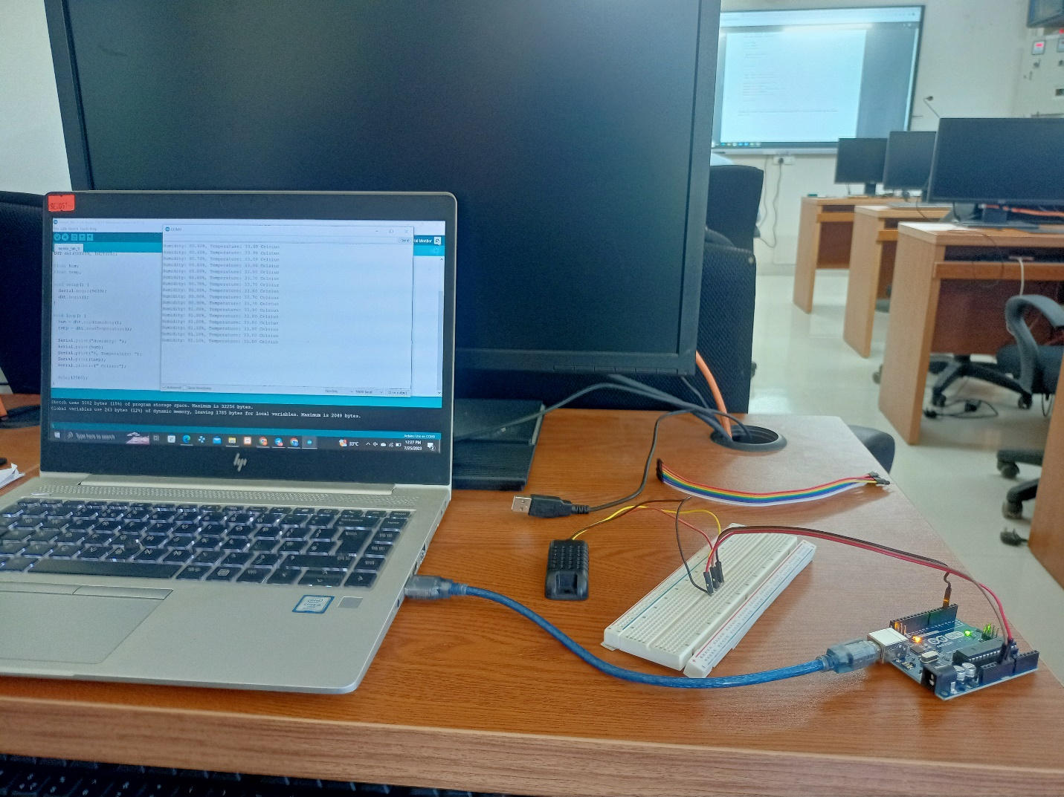

Code:

#include <dht.h>

#include<LiquidCrystal.h>

LiquidCrystal lcd(12,11,4,5,6,7);

#define DHT21PIN 9

dht DHT21;

void setup()

{

// Serial.begin(9600);

lcd.begin(20,4);

lcd.clear();

}

void loop()

{

//Serial.println();

int chk = DHT21.read(DHT21PIN);

//Serial.print("Humidity (%): ");

lcd.setCursor(0,0);

lcd.print("Humidity (%): ");

lcd.print(DHT21.humidity);

//Serial.println((float)DHT21.humidity, 2);

lcd.setCursor(0,1);

lcd.print("Temp(C): ");

lcd.print((float)DHT21.temperature, 2);

//Serial.println((float)DHT21.temperature, 2);

delay(2000)

RESULT and OUTPUT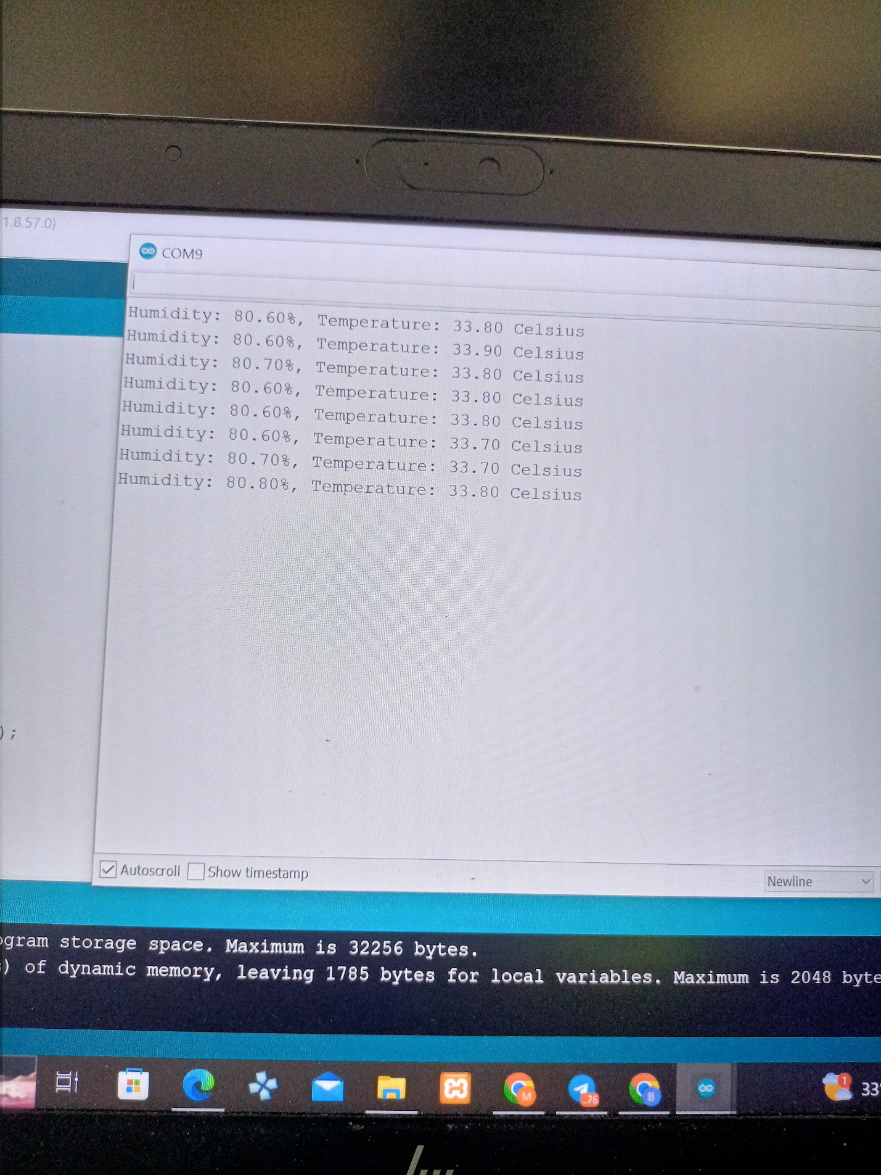

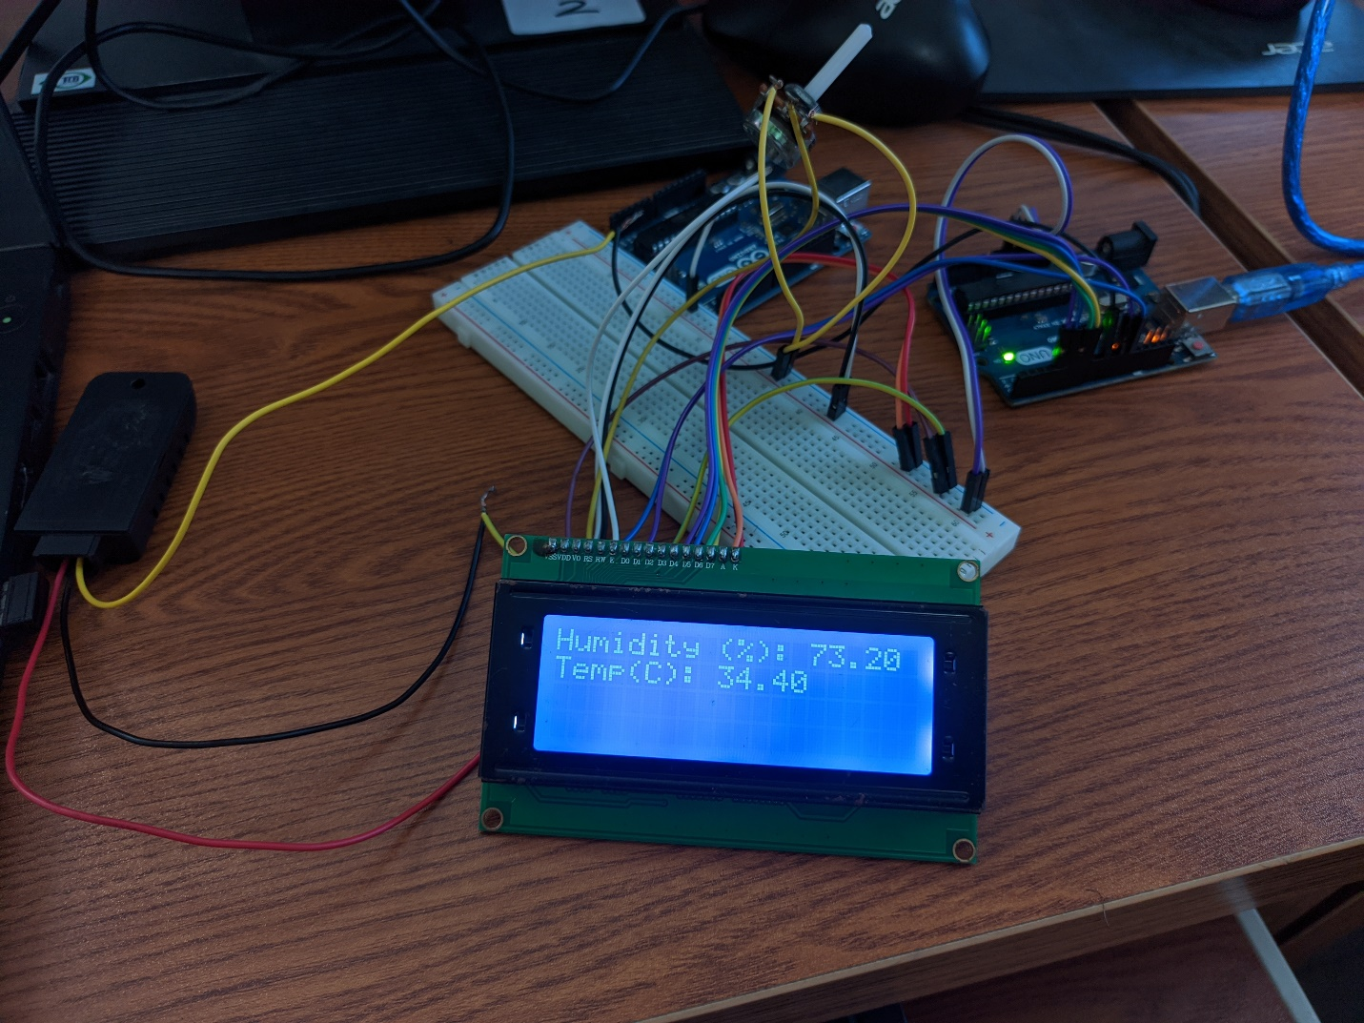

<https://drive.google.com/drive/folders/1rd9RpH94KXlBkUvYES_fsm17LKgVi16r>

Conclusion:

There has not happened any error occurrence while doing the experiment. The value displayed in proper way in both the LCD and Serial Monitor.